**How to Set Path and Classpath in Java**

**Path Variable**

Path variable is set for providing path for all Java tools like java, javac, javap, javah, jar, appletviewer which are used in java programming. All these tools are available in **bin** folders so we set path upto bin folders.

**Classpath Variable**

**Classpath** variable is set for providing a path for predefined Java classes which is used in our application. All classes are available in **lib/rt.jar** so we set classpath upto lib/rt.jar.

**Video Tutorial**

[How to Set Path and ClassPath in Java](https://www.youtube.com/watch?v=tUD5ilcqkiM)

**Why set path ?**

The following programming error is generally for all Java programmers when they compile any Java program.

**'javac' is not recognized as an internal or external command, operable program or batch file.**

When you get this type of error, then your operating system cannot find the Java compiler **(javac)**. To solve this error you need to set the PATH variable.

**Javac** is a tool which is available in bin folder so you must set the PATH upto bin folder. In a **bin** folder all tools are available like **javap, javah, jar, javac, java, appletviewer** etc. All these tools are used for different-different purpose.

#### Setting up path for windows ( 2000/XP/vista/Window 7,8 )

Assuming that you have installed Java in **C:\ Program files/ Java / JDK directory**

**Step 1**: Right click on my computer and select properties.

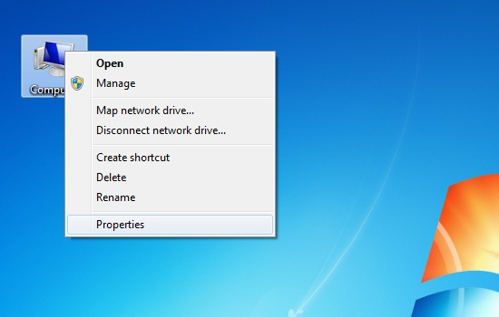

**Step 2**: Go to the Advance System Settings tab.

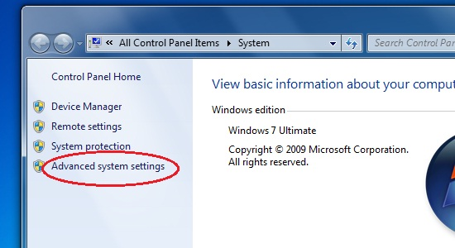

**Step 3**: Click on Environment Variables button.

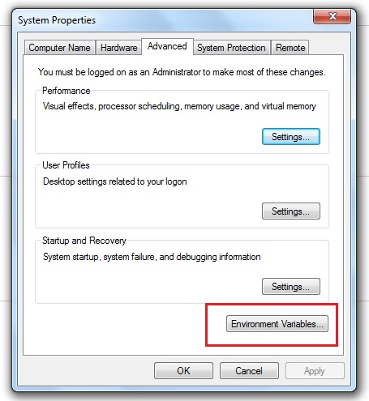

**Step 4**: Now alter the path variable so that it also contains the path to JDK installed directory.

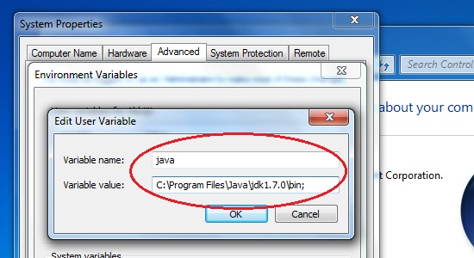

For e.g:- Change **C:\windows/ system 32.** to **C:\windows/system 32; C:\program files / Java/ JDK**.

#### Setting up path for window 95/98/ME

Assuming that you have installed Java in C:\program files\ java\ JDK directory, do the following:

**Step 1**: Edit the **C:\autoexec.bat** file and add the following line at the end.

SET PATH =% PATH% C:\ PROGRAM FILE/JAVA/JDK/bin

#### Setting up path for Linux , Unix , Solaris, free BSD

Assuming that you have installed Java in C:\program files\ java\ JDK directory, do the following:

**Step 1**: Environment variable path should be set to point where java binaries have been installed. Refer to your shell if you have trouble doing this.

**For Example:** If you use bash as your shell, then you would add following line to the end

bash mc: export PATH=/ Path/to/java

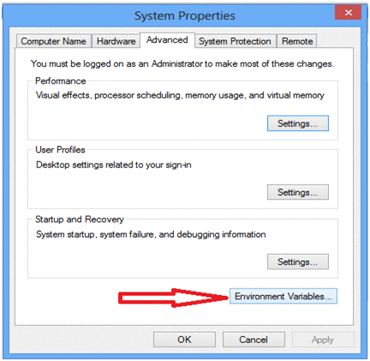

Click on new button which is below the first box.

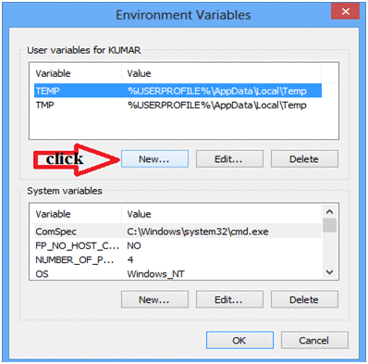

Now one dilog box is appear, now ignore this but do not close.

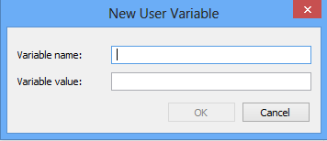

Now open my computer open c:/ > Programs Files > java > java1.6.0 > bin copy this path

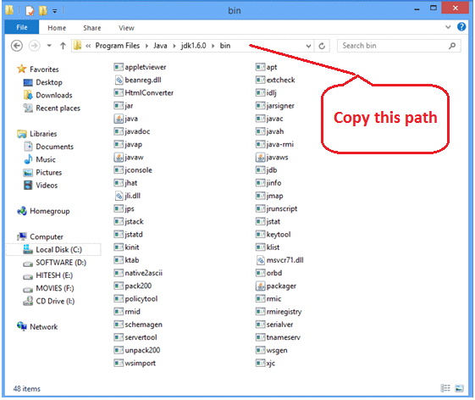

Now come back on previous open dilogbox and write variable name **'path'** and for variable value paste all copied path upto the bin folder. Put .; at the end. It (.) selects all the tools from the bin folder.

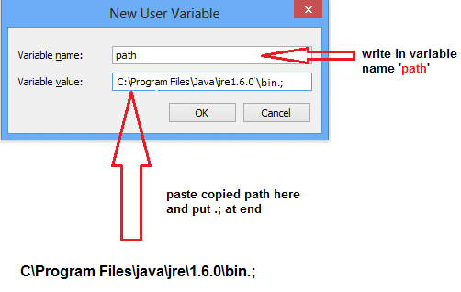

Now open my computer open c:/ > Programs Files > java > java1.6.0 > jre > lib > rt.jar copy this path

**Note:**rt.jar is available in lib folder this jar files contains all classes of jdk.

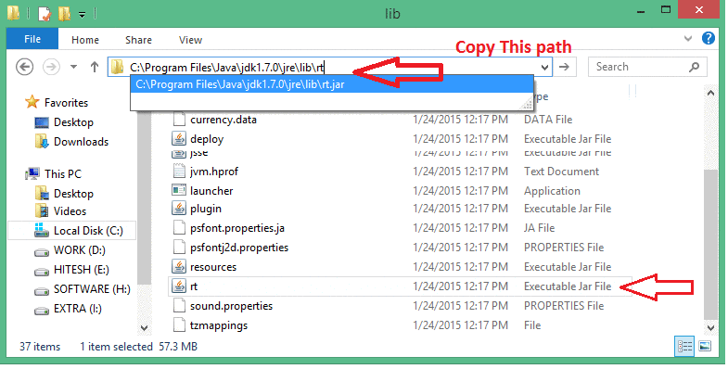

Now again come back on Environment variable dilogbox and click on new. Now one box is open and write path variable as **'classpath'** and for variable value paste all copied paths upto rt.jar. Put .; at the end. It (.) selects all the classes from lib folder.

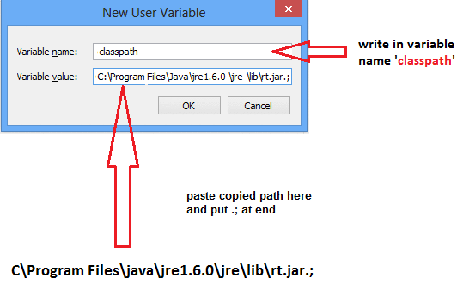

**Note:**Finally after set classpath Restart your system, or you can re-open command prompt.